Question 3 -5:

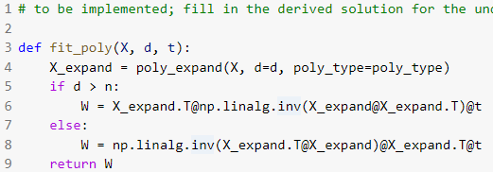

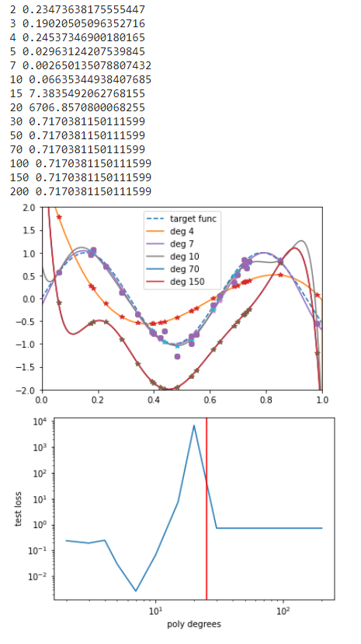

No, overparameterization does not always lead to overfitting. Here, overparameterization give stable and better performance than the medium range of parameters (9-35). Implicit regularization induced by gradient descent is reason for this trend.